Lab Exercise 2 - CTEs and Window Functions in PostgreSQL

1. Lab Overview
In this lab, you will learn how to use:
- Common Table Expressions (CTEs)
- CTEs to simplify complex queries
- Window functions for analytical queries
- ROW_NUMBER()
- RANK()
- DENSE_RANK()
We will use a simple employee sales dataset.
Estimated Time
30–45 minutes
Prerequisites
Basic knowledge of:
SELECT
WHERE
GROUP BY
ORDER BY
JOIN

2. Learning Objectives
By the end of this lab, you will be able to:
- Create and use a CTE.
- Break a complex query into simpler steps.
- Use window functions for analysis.
- Assign row numbers using ROW_NUMBER().
- Rank employees using RANK().
- Understand the difference between RANK() and DENSE_RANK().

3. Create the Database Table
Create a table:
CREATE TABLE employee_sales (
employee_id INT,
employee_name VARCHAR(100),
department VARCHAR(50),
sales_amount NUMERIC(10,2)
);
Insert sample data:
INSERT INTO employee_sales
(employee_id, employee_name, department, sales_amount)
VALUES
(1, 'Amit', 'IT', 85000),
(2, 'Priya', 'IT', 92000),
(3, 'Rahul', 'IT', 92000),
(4, 'Sneha', 'HR', 70000),
(5, 'Vikas', 'HR', 65000),
(6, 'Neha', 'HR', 70000),
(7, 'Rohit', 'Finance', 95000),
(8, 'Pooja', 'Finance', 88000),
(9, 'Ankit', 'Finance', 95000);
Check the data:
SELECT *
FROM employee_sales;
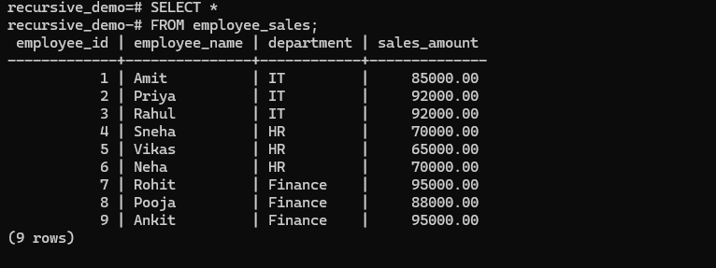
4. Exercise 1 – Basic CTE
A CTE allows us to create a temporary result that can be used by the main query.
Example:
WITH high_sales AS (
SELECT *
FROM employee_sales
WHERE sales_amount > 80000
)
SELECT *
FROM high_sales;
What happens?
The CTE:
high_sales
first finds employees whose sales are greater than 80000.
Then the main query reads from that result.
Expected employees include:
Amit
Priya
Rahul
Rohit
Pooja
Ankit

5. Exercise 2 – CTE for Department Statistics
Suppose we want to calculate the average sales for each department.
WITH department_sales AS (
SELECT
department,
AVG(sales_amount) AS average_sales
FROM employee_sales
GROUP BY department
)
SELECT *
FROM department_sales;
Expected result will look similar to:
department | average_sales
-----------+--------------
IT | 89666.67
HR | 68333.33
Finance | 92666.67
The CTE makes the query easier to understand.

6. Exercise 3 – CTE with Filtering
Now find departments where the average sales are greater than 85000.
WITH department_sales AS (
SELECT
department,
AVG(sales_amount) AS average_sales
FROM employee_sales
GROUP BY department
)
SELECT *
FROM department_sales
WHERE average_sales > 85000;
This is easier to understand than putting everything into one large query.

7. Exercise 4 – CTE with Multiple Steps
We can use multiple CTEs.
WITH department_sales AS (
SELECT
department,
AVG(sales_amount) AS average_sales
FROM employee_sales
GROUP BY department
),
high_performing_departments AS (
SELECT *
FROM department_sales
WHERE average_sales > 85000
)
SELECT *
FROM high_performing_departments;
The query works in two steps:
employee_sales
↓
department_sales
↓
high_performing_departments
↓
Final Result
This is one of the main advantages of CTEs: complex queries can be divided into logical steps.

8. Exercise 5 – ROW_NUMBER()
ROW_NUMBER() assigns a unique number to each row.
Run:
SELECT
employee_name,
department,
sales_amount,
ROW_NUMBER() OVER (
ORDER BY sales_amount DESC
) AS row_number
FROM employee_sales;
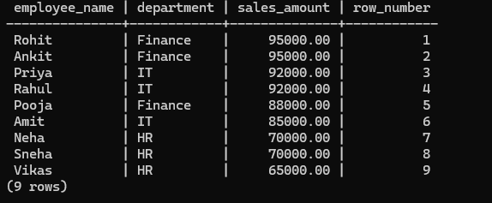
Example result:
employee | sales | row_number
---------+-------+-----------
Rohit | 95000 | 1
Ankit | 95000 | 2
Priya | 92000 | 3
Rahul | 92000 | 4
Pooja | 88000 | 5
Amit | 85000 | 6
...
Notice that even employees with the same sales receive different row numbers.

9. Exercise 6 – ROW_NUMBER() by Department
We can restart the numbering for every department.
SELECT
employee_name,
department,
sales_amount,
ROW_NUMBER() OVER (
PARTITION BY department
ORDER BY sales_amount DESC
) AS row_number
FROM employee_sales;
The important part is:
PARTITION BY department
It means:
Start numbering again for each department.
Example:
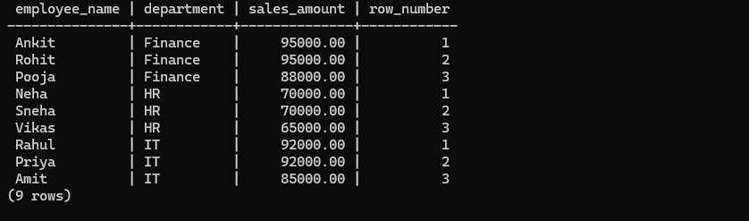
IT
Priya 92000 1
Rahul 92000 2
Amit 85000 3
and:
HR
Sneha 70000 1
Neha 70000 2
Vikas 65000 3

10. Exercise 7 – RANK()
Now use RANK().
SELECT
employee_name,
department,
sales_amount,
RANK() OVER (
ORDER BY sales_amount DESC
) AS sales_rank
FROM employee_sales;
If two employees have the same sales, they receive the same rank.
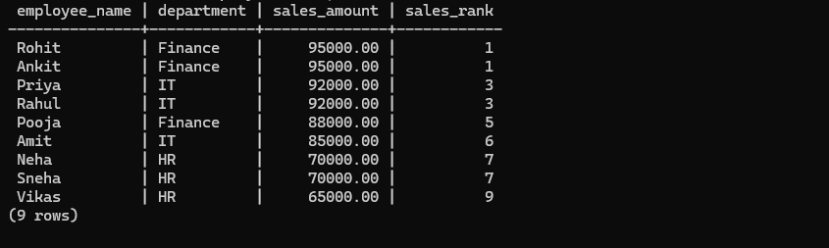
For example:
Rohit 95000 1
Ankit 95000 1
Priya 92000 3
Rahul 92000 3
Pooja 88000 5
Notice the gap after tied values.

11. Exercise 8 – DENSE_RANK()
Now use:
SELECT
employee_name,
department,
sales_amount,
DENSE_RANK() OVER (
ORDER BY sales_amount DESC
) AS sales_rank
FROM employee_sales;
Result:
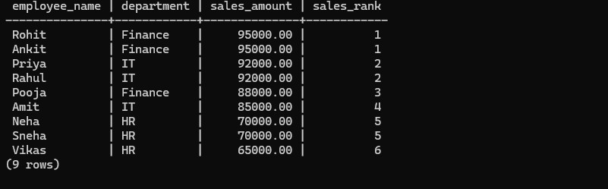
Rohit 95000 1
Ankit 95000 1
Priya 92000 2
Rahul 92000 2
Pooja 88000 3
Amit 85000 4
Unlike RANK(), DENSE_RANK() does not skip numbers.

12. Exercise 9 – Understand the Difference
Run all three functions together:
SELECT
employee_name,
sales_amount,

ROW_NUMBER() OVER (
ORDER BY sales_amount DESC
) AS row_number,

RANK() OVER (
ORDER BY sales_amount DESC
) AS rank,

DENSE_RANK() OVER (
ORDER BY sales_amount DESC
) AS dense_rank

FROM employee_sales;
You will see something like:
Employee | Sales | ROW_NUMBER | RANK | DENSE_RANK
---------+-------+------------+------+-----------
Rohit | 95000 | 1 | 1 | 1
Ankit | 95000 | 2 | 1 | 1
Priya | 92000 | 3 | 3 | 2
Rahul | 92000 | 4 | 3 | 2
Pooja | 88000 | 5 | 5 | 3
Remember
ROW_NUMBER()
Every row gets a unique number.

RANK()
Same values get the same rank,
but gaps are created.

DENSE_RANK()
Same values get the same rank,
without gaps.

13. Exercise 10 – Find Top Employee in Each Department
This is a very common real-world use case.
First create a ranking:
WITH ranked_employees AS (
SELECT
employee_name,
department,
sales_amount,
ROW_NUMBER() OVER (
PARTITION BY department
ORDER BY sales_amount DESC
) AS row_number
FROM employee_sales
)
SELECT *
FROM ranked_employees
WHERE row_number = 1;
This returns the highest-selling employee from each department.
Example:
IT | Priya | 92000
HR | Sneha | 70000
Finance | Rohit | 95000

14. Exercise 11 – Find Top 2 Employees in each department
Modify the previous query:
WITH ranked_employees AS (
SELECT
employee_name,
department,
sales_amount,
ROW_NUMBER() OVER (
PARTITION BY department
ORDER BY sales_amount DESC
) AS row_number
FROM employee_sales
)
SELECT *
FROM ranked_employees
WHERE row_number <= 2;
This returns the top two employees from every department.
